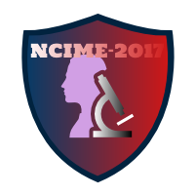

**How to pay Fees**

Authors can pay fees offline or online.

**For offline payment:**

**DD in favour of ‘Principal, Sinhgad Institute of Technology’, payable at Pune.**

**For Online payment: (NEFT/RTGS)**

**A/c Name:** Shri Anand Co-op bank ltd.

**Bank Name:** Cosmos co. op. Bank ltd.

**Current A/C No**.: 006204301200049

**Branch Name**: Chinchwad

**IFSC Code:** COSB0000006

**MICR:** 411164010